**Nishida Kitarō**

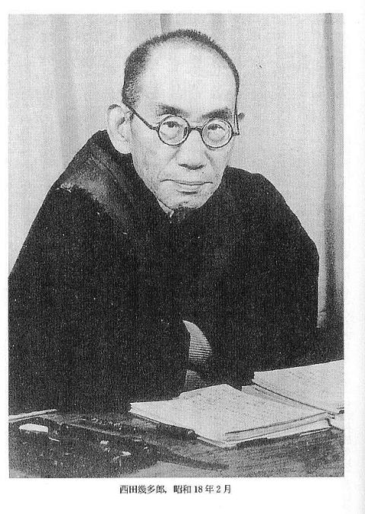

Nishida in 1943. <http://commons.wikimedia.org/wiki/File:Kitaro_Nishidain_in_Feb._1943.jpg#/media/File:Kitaro_Nishidain_in_Feb._1943.jpg>; Image in the public domain.

Summary:

Arguably the most important Japanese philosopher of the twentieth century, Nishida Kitarō (西田 幾多郎; 1870-1945) was one of the first thinkers to deeply engage with the sudden massive influx of foreign ideas that characterized the Meiji era, while still maintaining a distinctive place for Asian ideas. Beginning with *An Inquiry into the Good* (1911), Nishida’s lifelong philosophical goal was to identify the foundation of consciousness and existence, something he would later call the “place” (*basho*). Successive works identified this foundation as “pure experience,” “absolute will,” and, finally, “absolute nothingness.” All these “places” have in common that they lack any distinctive features: as fields (another term Nishida employs) that contain oppositions (such as subject-object, me-you, knowledge-feeling), they cannot of themselves have distinguishable qualities.

Though Nishida’s actions during the Pacific War have been the subject of significant debate, his influence is uncontested: the so-called Kyoto School of Japanese philosophy consists of those building on or reacting to his ideas. Because he valued both Christian and Buddhist traditions, Nishida has also been a pivotal figure in East-West religious dialogue.

Main Entry

Nishida was born in Mori Village, north of the city of Kanazawa. Having familiarized himself with Chinese, English and German languages and thought in high school, he studied philosophy at Tokyo Imperial University. After a career teaching high school, he was offered a position at Kyoto Imperial University in 1914, where he would teach until his retirement in 1929. A lay practitioner of Zen Buddhism, Nishida would be haunted by personal suffering, witnessing the deaths of his first wife and four of his children.

Nishida’s first book, *An Inquiry into the Good* (1911), posits “pure experience” at the source of all consciousness. Adopting the term from William James’ work on religious experience, Nishida proposed that there exists an experience before the intrusion of rational or intellectual distinctions such as subject-object, thought-feeling, individual-universal, and so forth. All these opposites derive from pure experience, which precedes it as their ground and condition. Because of this a priori position beyond reason, thought or logic cannot grasp pure experience. Nevertheless, Nishida claims that pure experience can be accessed by any human being willing to take the time to train his or her mind, though he suggests that the Japanese have a particular talent for this: in the art of the master swordsman, the meditation of the Zen monk, the perfect manners of the tea ceremony, he sees the best ways to access pure experience.

In what some (Carter 2013) see as an attempt to extend the idea of pure experience beyond psychology but what others (Maraldo 2012) have called a deepening of that earlier theme, Nishida's later work features the term “absolute nothingness” (*zettaimu* 絶対無) as the formless ground of everything. Here too, the only manner of accessing this ground is via the “intuition,” that is to say spontaneous, direct experience. Since this ground is beyond even the opposition reality-illusion (because it makes such oppositions possible, enveloping them), Nishida, drawing on Plato’s *Timaeus*, calls it a *basho*(場所), a “place.” Though this “place” is formless or undetermined in itself, it is endlessly determinable: without any agent or object, it multiplies in endless creative visions of itself that then constitute individual consciousnesses. At the same time, however, such consciousnesses remain identical with their origin. Nishida stresses that language must speak in logical contradictions to express this point: I am part of the universal, and yet I am separate from it. In an essay written towards the end of his life, Nishida described this otherness within the self as death, which pervades every moment of life as an opening to the universal.

In the 1930s, responding to Marxist critiques of his work that targeted his stress on the universal and his neglect of the possibilities of human agency, Nishida formulated a theory of the historical world based on the aforementioned concepts. In brief, if the foundation of reality is absolute nothingness, there is endless creative possibility at any given historical moment, as the emergence of a new perspective out of the formless is always possible. Everybody is potentially such a co-creator in history.

Nishida’s ideas were very influential both in Japan and abroad. In Japan, the so-called Kyoto school developed his thinking further, especially the concept of "absolute nothingness” (Carter 2013). During the Pacific War, Nishida and some of his Kyoto School colleagues put forward positions that some have seen as supporting the Japanese nation-state and the war, whereas others have defended Nishida and his peers as forces implicitly criticizing the totalitarian and imperialist nation their country had become (see Heisig & Maraldo 1995).

Through his students in Germany, Nishida first gained international renown in the 1920s and 30s, but his reputation would really take off after the war. Through his influence on his childhood friend and famous Zen apologist Daisetz Teitaro Suzuki, the idea that experience (and not reason) is foundational to all human religions gained currency far beyond departments of Asian philosophy. Rather ironically, this position was then considered a quintessentially Japanese antidote to the dead ends of western thought, but as we have just seen Nishida developed it partly under the influence of European and American thinkers (see Sharf 1993).

**Nishida’s Works in Japanese**

*Nishida Kitarō Zenshū* (Complete Works). New Edition 2002–09, twenty four volumes, edited by A. Takeda, K. Riesenhueber, K. Kosaka & M. Fujita, Tokyo: Iwanami Shoten, 2002-2009. New Edition. This is the complete, Japanese-language edition of Nishida’s work.

**List of Representative Works Available in English Translation**

Note: After the title, I have parenthetically indicated the year of publication of the original Japanese work.

*An Inquiry into the Good* (1911). Masao Abe and Christopher Ives (trans.), New Haven and London: Yale University Press. 1990.

*Intuition and Reflection in Self-Consciousness* (1913-1917). Valdo H. Viglielmo, Takeuchi Toshinori and Joseph S. O'Leary (trans.), Albany: State University of New York Press, 1987.

*Art and Morality* (1923). David Dilworth and Valdo Viglielmo (trans.), Honolulu: University of Hawai'i Press, 1973.

*The Fundamental Problems of Philosophy* (1933-4). David Dilworth (trans.), Tokyo: Sophia University, 1970.

*Last Writings: Nothingness and the Religious Worldview* (1945). David Dilworth (trans.), Honolulu: University of Hawai'i Press. 1987.

**References and Further Reading**

Robert E. Carter. *The Kyoto School: An Introduction*. Albany: SUNY Press, 2013.

Heisig, James W. *Philosophers of Nothingness: An Essay on the Kyoto School*. Honolulu: University of Hawai’i Press, 2001.

--- and John C. Maraldo, eds. *Rude Awakenings: Zen, the Kyoto* *School, and the Question of Nationalism*. Honolulu: University of Hawai’i Press, 1995.

Maraldo, John C. “The Kyoto School.” *Japanese Philosophy, A Sourcebook*. Edited by Heisig, Thomas P. Kasulis, Maraldo. Honolulu: University of Hawai’i Press, 2011. 637-45.

---. “Nishida Kitarō,” *The Stanford Encyclopedia of Philosophy*, Edward N. Zalta, ed. 2005. Rev. 2012.  url: <http://plato.stanford.edu/archives/sum2010/entries/nishida-kitaro/>

Nishitani Keiji, *Nishida Kitarō*, tr. Yamamoto Seisaku and Heisig. Berkeley: Berkeley UP, 1991.

Sharf, Robert H. “The Zen of Japanese Nationalism.” *History of Religions* 33.1 (1993). 1-43.

Yusa Michiko. *Zen and Philosophy: An Intellectual Biography of Nishida Kitarō*. Honolulu: University of Hawai'i Press, 2002.

Wargo, Robert. *The Logic of Nothingness: A Study of Nishida Kitarō*. Honolulu: University of Hawai’i Press, 2005.